

Professional High School

**THIRD QUARTER**

**ICT 9** Seatwork 1: Applying Bootstrap

NAME: __Angelie Beatrice L. Ringor­____________________________ SCORE: _______________

GRADE-SECTION: 9-Ruby____________ DATE: _13/02/2023________

**Directions:**Read and understand the instructions.

1. Create a website about your favorite TV Show discuss the following:
2. Synopsis/Summary/Introduction of the TV Show
3. Characters of the TV Show
4. Apply Bootstrap 4 on your website.
5. Apply Bootstrap 4 Grid System
6. Apply Bootstrap Colors to texts and background.
7. Create a repository in github and name it:

***CAMPUS_ICT9Section_Q3SW1_Lastname Firstname***

1. Upload your Seatwork 1 files to the repository.
2. Publish it on Github Pages
3. Send in the digital platform the link for your Github repository and Github pages

|  |  |  |  |  |  |
| --- | --- | --- | --- | --- | --- |
| **CRITERIA** | **E = 5** | **AS = 4** | **S = 3** | **NI = 2** | **P = 1** |
| Structure | * Proper Use of HTML Tags * Basic HTML Structure * Proper use of file extensions | * Proper Use of HTML Tags * Basic HTML Structure | * Not all of the required HTML tags are used * Basic HTML Structure | * Only the Basic HTML Structure was used | * Basic HTML Structure was not properly executed |
| Bootstrap Script & Design | * Bootstrap implementation * Proper use of Bootstrap Grid and Color * Color Combinations * Use of Design | * Bootstrap implementation * Proper use of Bootstrap color but grid was not used * Color Combinations * Use of Design | * Bootstrap implementation * Color Combinations * Use of Design | * Bootstrap implementation * Did not use color combination | * Bootstrap was not implemented * Did not use color combination and does not use any designs |
| Execution of Instructions | * The Files were uploaded to Github Properly * The Github Pages is properly established * The Repository is name properly * The Link to the Repository and Pages were passed via OB Digital Platform | * The Files were uploaded to Github Properly * The Github Pages was not properly established * The Repository is name properly * The Link to the Repository and Pages were passed via OB Digital Platform | * The Files were uploaded to Github Properly * The Github Pages was not established and named properly * The Link to the Repository and Pages were passed via OB Digital Platform | * The Files were not uploaded to Github Properly * The Github Pages was not established and named properly | * The Files were not uploaded to Github Properly * The Github Pages was not established and named properly * Sent only a a screenshot of the code and output |
|  |  |  |  |  |  |
| **TOTAL** | **20** | **8** | **6** | **4** | **2** |

CODES:

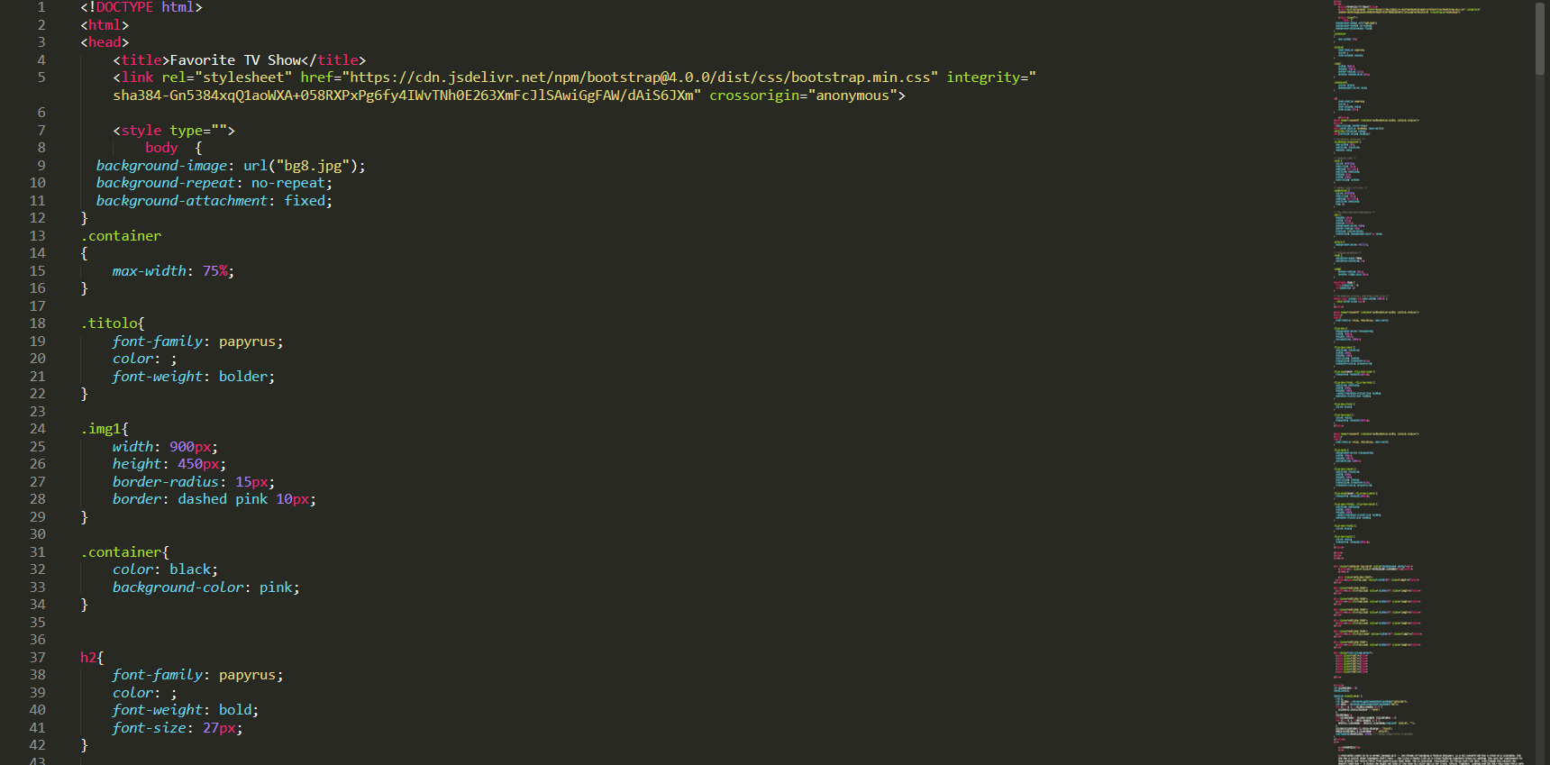

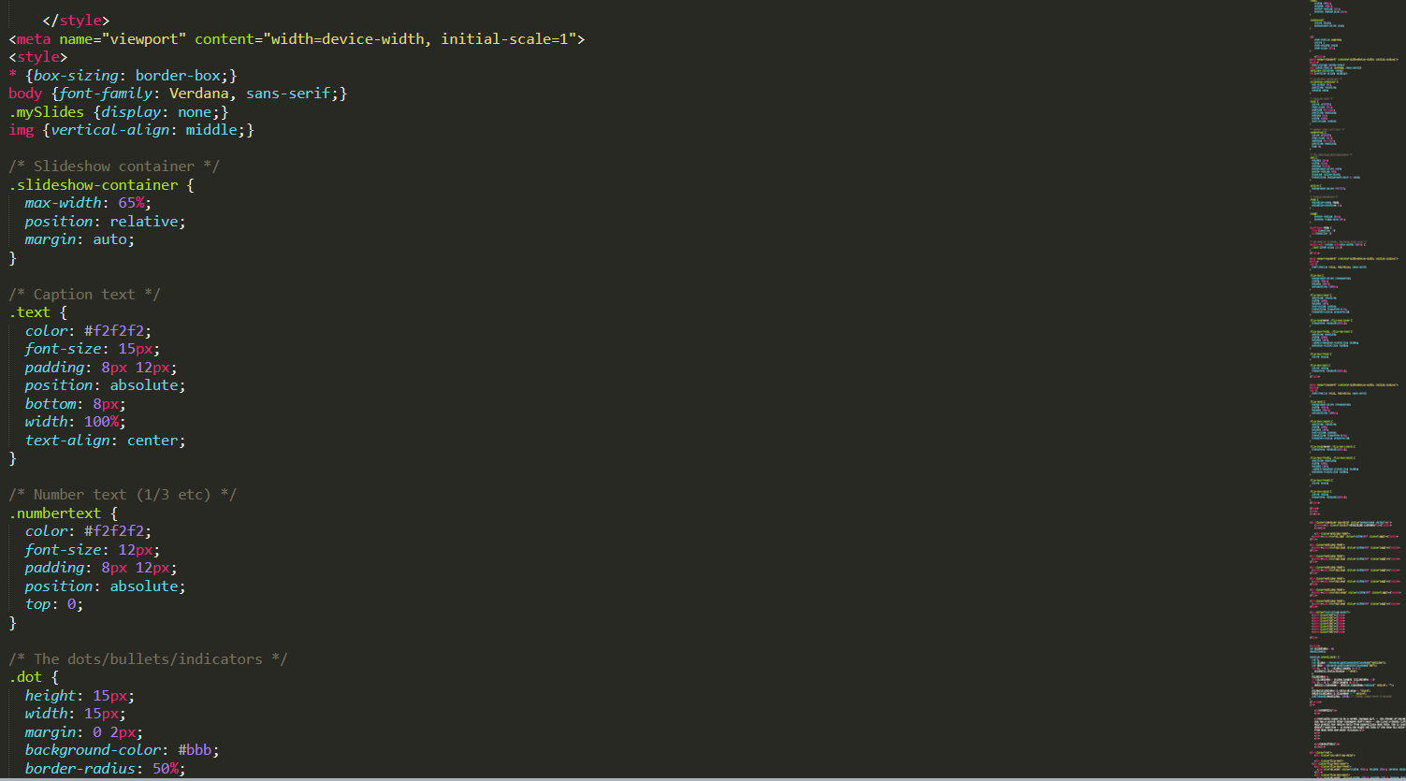

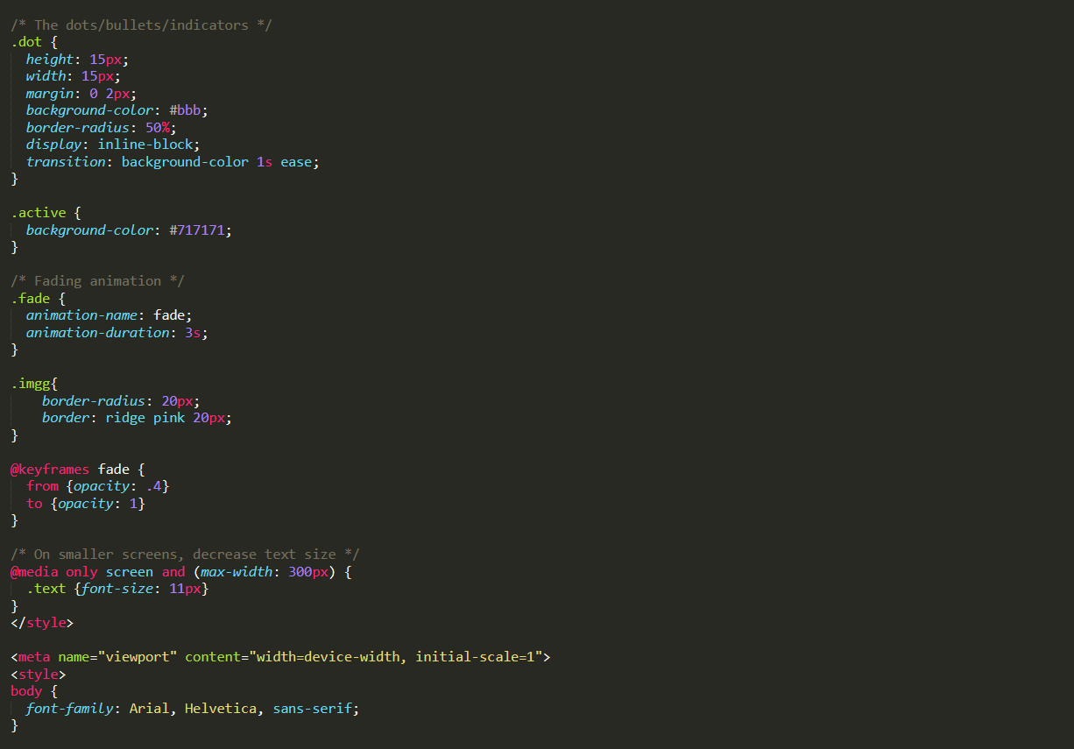

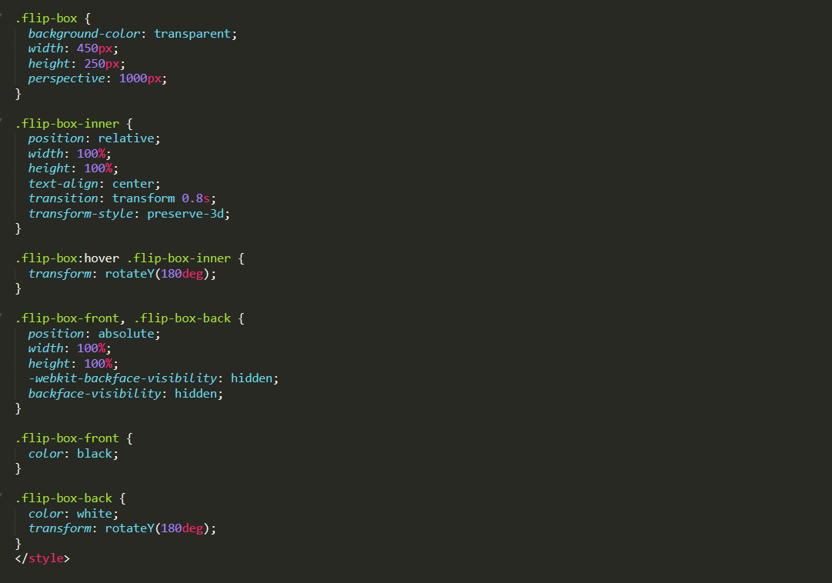

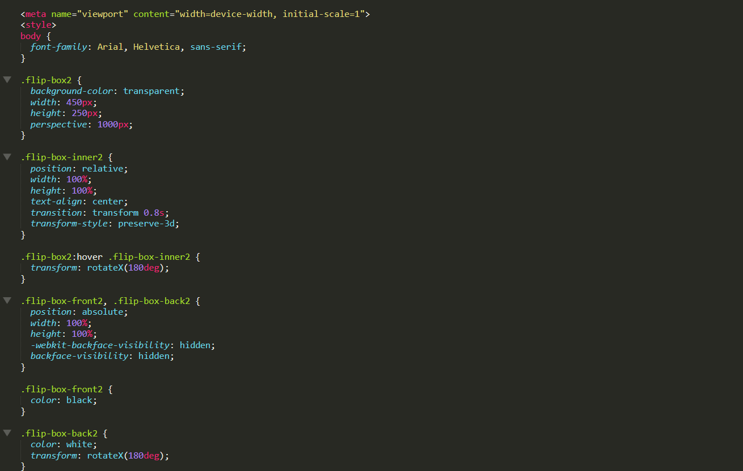

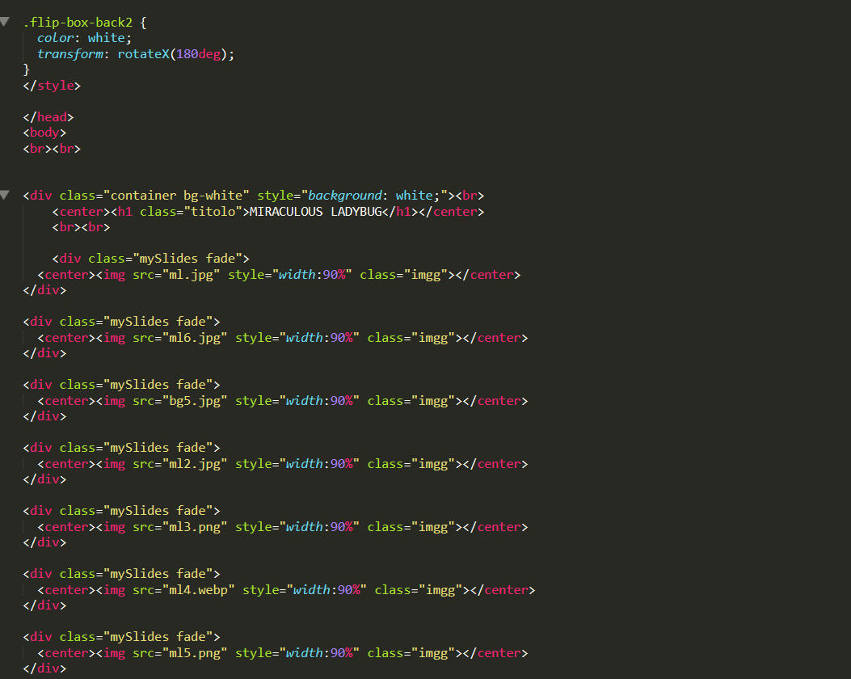

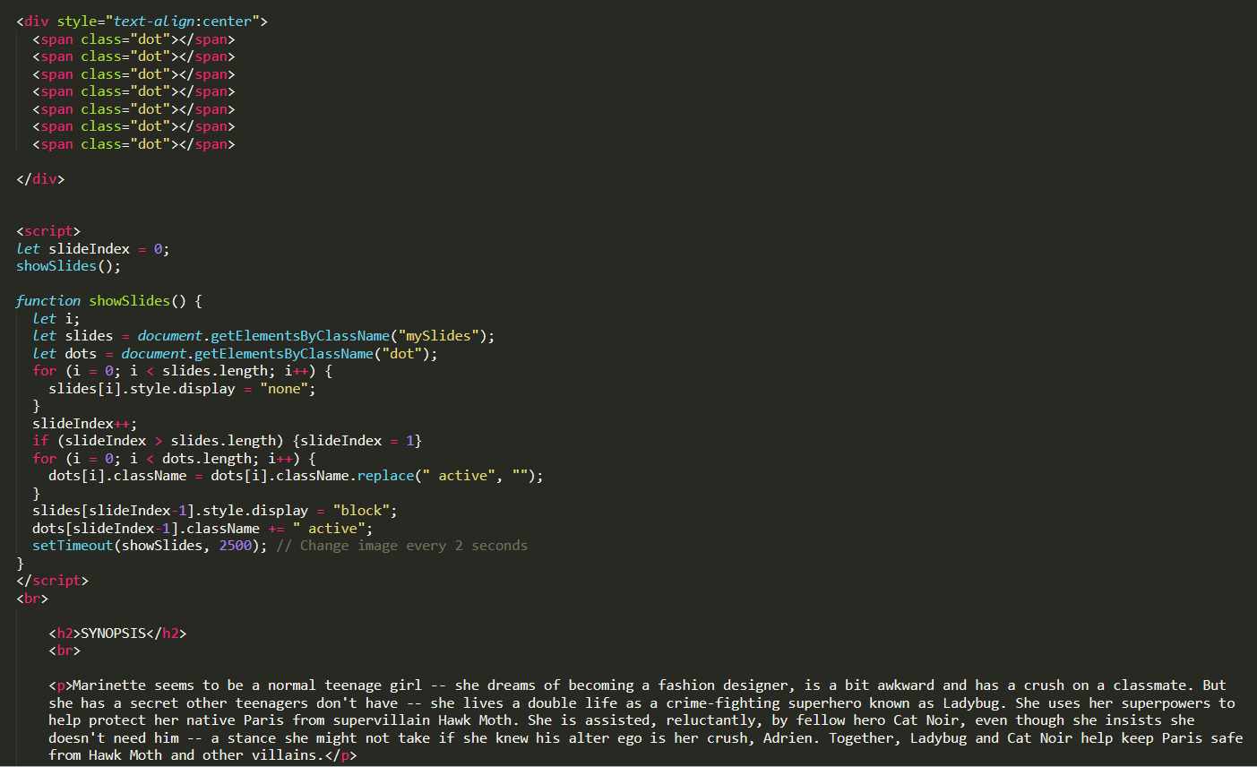

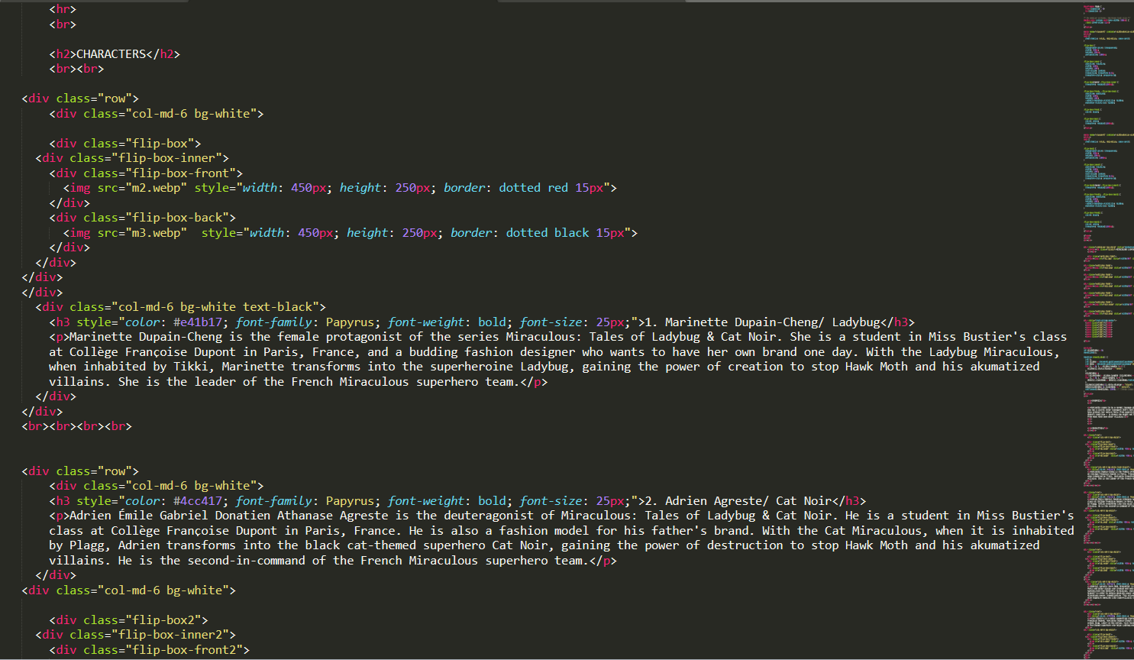

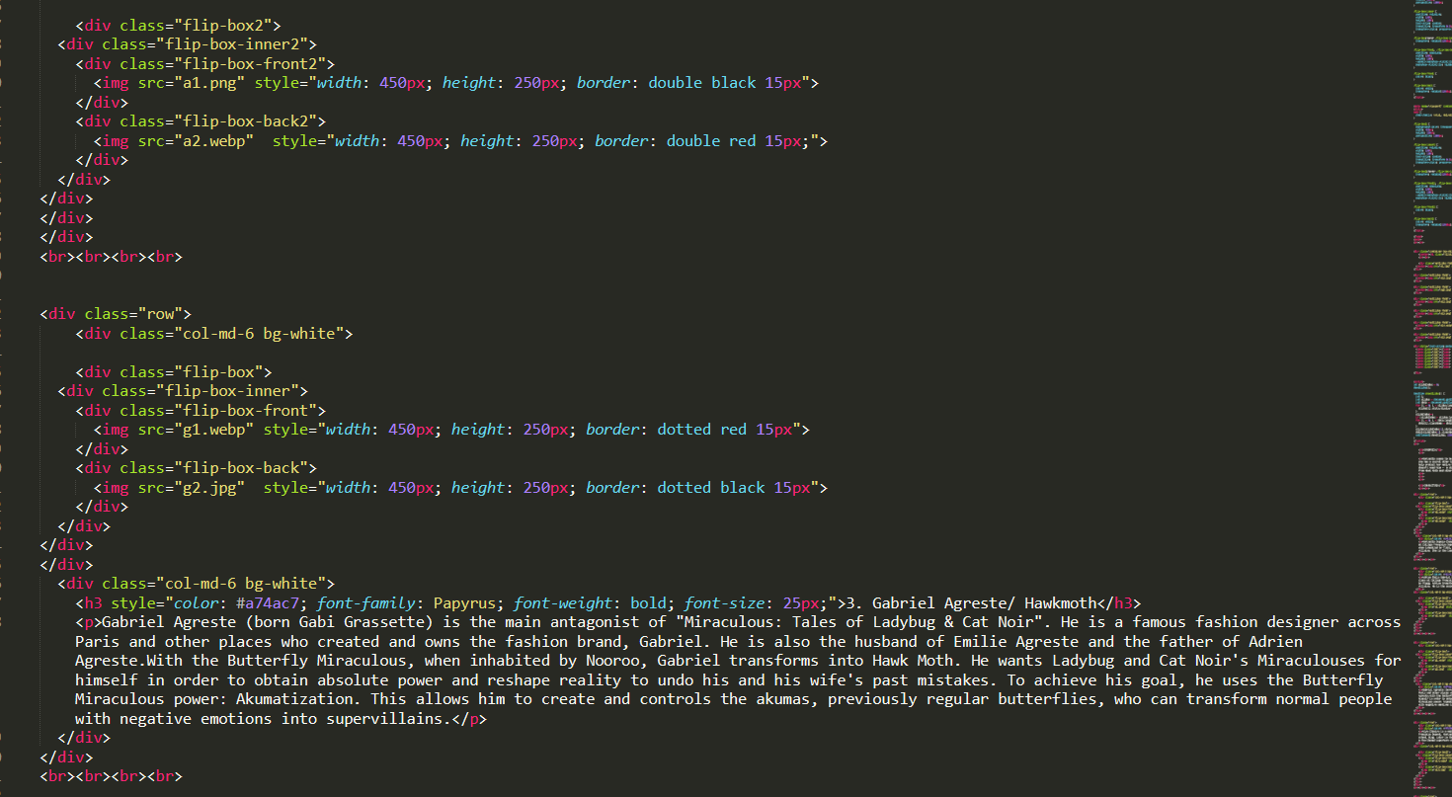

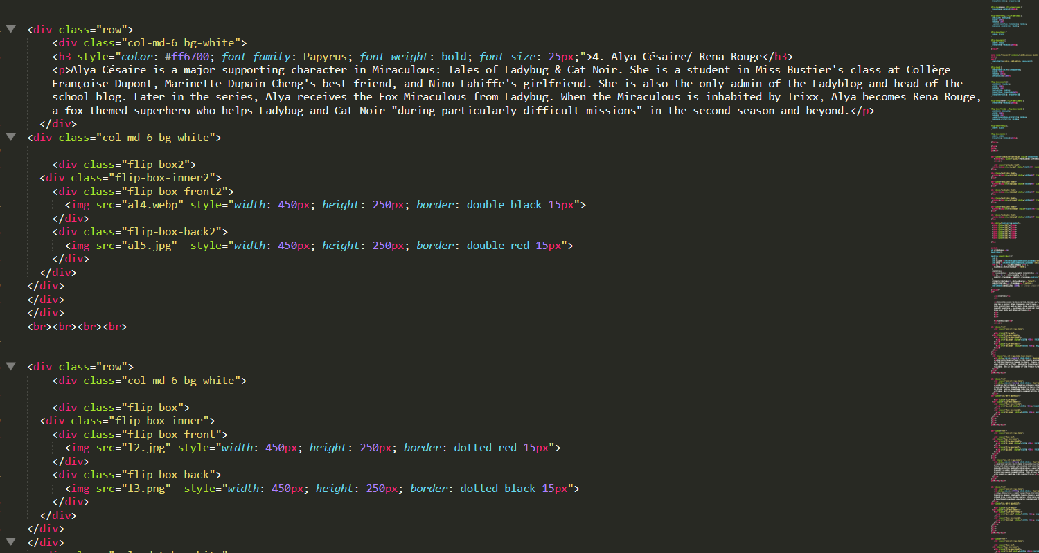

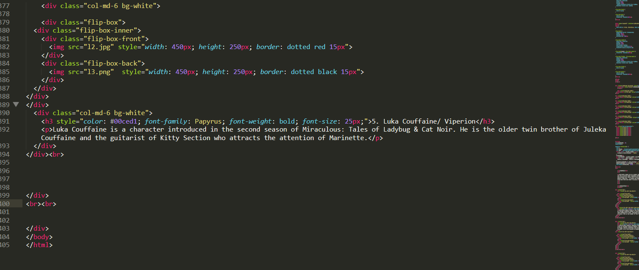

WEBSITE

